Performance Test Strategy
for


Version V1.0

Contents

1. Introduction 5
1.1 Purpose 5
1.2 In Scope 5
1.3 Out of Scope 6
1.4 Performance Test Schedule 6
1.5 Non Functional Requirements 6
2. Performance Testing Approach 7
2.1 Overview 7
2.2 Entry Criteria 7
2.3 Types of Performance tests 7
2.4 Exit Criteria 8
2.5 Performance Test Risk assessment 8
3. Test Environment 9
3.1 High Level System Architecture 9
3.2 Software and Hardware – check with sajeevi 9
4. Test Execution 11
4.1 Test Scenarios and Workload Distribution 11
4.2 Types of Test 11
4.3 Test Phases of Performance Testing 11
4.4 Test Data 12
4.5 Monitoring 14
4.6 Test Tools 14
4.7 Test Metrics & Reporting 14
5. Performance Testing Assumptions, Risks & Dependencies 15
5.1 Assumptions 15
5.2 Risks 15
5.3 Dependencies 15
5.4 Defect Management 16
5.5 Definition 17
6. Performance Deliverables 18
6.1 Performance Deliverables sign-off 18

Document Control
Version history

Version | Date | Author | Version description
1.0 | 25/8/2016 | Madhushani Tilakaratne | Initial Draft

Reviewers
Role | Name | Date

Approval
Role | Name | Approval | Date

Abbreviations and Nomenclature
Abbreviation | Expansion
TBD | To Be Decided
QA | Quality Assurance
DB | Database
AppServer | Application Server
WS | Web Service
PT | Performance Test
CPU | Central Processing Unit
NA | Not Applicable
NFT | Non Functional Test

Introduction

Purpose
The purpose of this document is to define the performance objectives, strategy, approach and measurement criteria for the Akura application, along with certain additional information regarding the performance testing effort.
This test strategy will be used as the basis for all performance testing activities that will be carried out during this project.

In Scope
This following scenarios are the key scope inclusions for the Akura application performance test.
S. No | Scenario | Description
1 | Bulk upload of Student and Parent details | Server must operate within CPU and Memory and Response time boundaries while users are concurrently uploading details about Students and Parents.
2 | Bulk Update of Student Details | Server must operate within CPU and Memory and Response time boundaries while users are concurrently uploading the changes made to existing students details.
3 | Export Student Details | Server must operate within CPU and Memory and Response time boundaries while users are concurrently exporting student details available in the system according to different filtering criteria.
4 | Attendance Mark Entry | Server must operate within CPU and Memory and Response time boundaries while teachers are concurrently marking the student attendance through the system.
5 | Term Mark Entry | Server must operate within CPU and Memory and Response time boundaries while teachers are concurrently marking the student term marks through the system.
6 | Import Term Marks | Server must operate within CPU and Memory and Response time boundaries while teachers are concurrently uploading student term marks to the system.
7 | Export Term Marks | Server must operate within CPU and Memory and Response time boundaries while teachers are concurrently exporting student term marks from the system.
8 | View Reports – Grade Wise Term Mark Graph, Prize List, Class Wise Student Mark Sheet, Report Card, Student Summary Report | Server must operate within CPU and Memory and Response time boundaries while users are generating the following reports:  - Grade Wise Term Mark Graph  - Prize List  - Class Wise Student Mark Sheet  - Report Card  - Student Summary Report  - Annual Student Attendance Report
9 | Search Students & Staff | Server must operate within CPU and Memory and Response time boundaries while users are concurrently searching for students and staff members.
10 | Review of Children’s Academic Performance by Parents | Server must operate within CPU and Memory and Response time boundaries while parents are concurrently viewing the academic performance (Academic Life) of their children.

Out of Scope
Any scenarios that is not mentioned in the above table are not considered for this initiative and thus will be out of scope.

Performance Test Schedule

9 Sep | 12 Sep | 13 Sep | 14 Sep | 15 Sep | 19 Sep | 20 Sep | 21 Sep | 22 Sep | 23 Sep | 26 Sep | 27 Sep | 28 Sep | 29 Sep | 30 Sep
Performance Scripts Development |  |  |  |  | Test Execution |  |  |  |  | Analysis & Report

Non Functional Requirements
<Details of shared and finalised non-functional requirements>
What should come here??????

Performance Testing Approach

Overview
Performance testing is designed to measure the systems responsiveness under load and predict the likely response times when used in the live environment.

Identified functionalities will be scripted and multiple concurrent users will be simulated to measure the application performance.

Entry Criteria
- The performance environment has the baseline code (latest).
- Performance Test key transactions have been identified, documented and approved
- Performance Test data is available and established in the performance test environment
- No critical “showstopper” functional defects on transaction flows covered in performance test scenarios.
- Access granted to performance test region, application and environments.

Types of Performance tests

- Baseline System Performance Test
- Load Test ( Will vary from single user to different # of concurrent users depending on the scenario under test)
- Scalability Test (Only the scalability of the system based on varying number of users. No hardware scalability)
- Stress Test ( will increase the # of concurrent users until the system completely fails and see how the system fails )

Performance testing types | Main Objective | Scope of each test
Single user baseline | All scenarios will be recorded for future comparison | Measure the response times for the system for any deviations.
Load test | All scenarios will be executed for single to different number of concurrent users to measure the response times | Measure the response times based on the by varying concurrent users.
Scalability Testing | Only the scalability of system based on varying number of users. No hardware scalability | To see if the system is capable of handling the current defined concurrent user load and also by increasing the defined user load to see systems capability of handling them.
Stress Test | Need to increase the number of concurrent users until the system completely fails | During this test we will Monitor server CPU utilizations and Memory utilizations

Smoke Tests
A smoke test is a test run under very low load that merely shows that the application works as expected. If smoke is generated, the test fails and no further testing is necessary until the simplest test passes success.

Load Tests
The load test is conducted to benchmark the response of Akura application under the peak loads. Server statistics of web and app will be monitored during the test execution.
App servers CPU and Memory will be monitored.

Endurance Tests
This is to ensure that the Akura application can sustain prolonged load for 8 hours duration. Server statistics would be monitored during the test to understand if there are any anomalies reported over the course of the test.

Exit Criteria
- Test execution for all test scenarios planned should completed
- Response times for all business transactions should captured and be less than or equal to 5 seconds.

Performance Test Risk assessment
<Risks related to the test and the mitigation plan>

What is this for? We have already captured risks in another section?

Test Environment

High Level System Architecture
Email Service
Utility Services
Logging
Exception Handling
Audit Service
Presentation Layer
JSP
Business Layer
Filters
Tag Libraries
Controllers
Common Service
Student Service
Staff Service
Data Access Layer
School Service
Reporting Service
Attendance Service
Common Dao
Student Dao
Staff Dao
School Dao
Reporting Dao
Attendance Dao

Email Service
Utility Services
Logging
Exception Handling
Audit Service
Presentation Layer
JSP
Business Layer
Filters
Tag Libraries
Controllers
Common Service
Student Service
Staff Service
Data Access Layer
School Service
Reporting Service
Attendance Service
Common Dao
Student Dao
Staff Dao
School Dao
Reporting Dao
Attendance Dao

Software and Hardware – check with sajeevi

No. | Machine | Purpose | Software Requirements | Hardware Configuration | Quantity
1. | App Server | Installation of the application | - Apache Tomcat 8.0.36  - Linux - 3.14.20-20.44.amzn1.x86_64 | - Processor: Genuine Intel, Intel(R) Xeon(R) CPU E5-2670 v2 @ 2.50GHz  - RAM: 4GB | 1
2. | DB Server | Database server to support the Content Management Tool | - MySQL Version: mysql Ver 14.14 Distrib 5.5.40, for Linux (x86_64) using readline 5.1 | - Processor: Genuine Intel, Intel(R) Xeon(R) CPU E5-2670 v2 @ 2.50GHz  - RAM: 4GB | 1
3. | Windows Client | For execution of test cases in the Windows environment | OS: Windows 7 | Processor : Intel(R) Core(TM) 2 Duo CPU 2.93GHz  RAM : 4 GB  HDD: 160 GB | 1

Test Execution

Test Scenarios and Workload Distribution
Once the application is deployed following maximum user loads are expected to support for Akura application.

S. No | Performance Test Scenario | SLA  Secs | Number of Users
S. No | Performance Test Scenario | SLA  Secs | Load  Test | Stress  Test | Endurance  Test
1 | Bulk upload of Student and Parent details |  | 10
2 | Export Student Details |  | 3
3 | Bulk Update of Student Details |  | 5
4 | Attendance Mark Entry |  | 50
5 | Import Term Marks |  | 20
6 | Freeze Term Marks |  | 25
7 | Export Term Marks |  | 10
8 | View Reports |  | 5
9 | Search Students & Staff |  | 3
10 | Review of Children’s Academic Performance by Parents |  | 100

Types of Test

Test  ID | NFT Area | Test Description | Duration
TID01 | Smoke Test | To verify if the scripts are working fine on the environment | 15 mins
TID02 | Load Test | To capture the application response time under peak load and identify any performance bottlenecks | 1 hour
TID03 | Soak Test | To find system sustainability for a duration of 8 hrs. | 8 hours

Test Phases of Performance Testing
The Performance test effort will be carried out in two phases:
- Phase 1 –
Benchmark Test - Performance benchmarking for the identified scenarios for the current recommended configurations.
- Phase 2 –
Load and scalability test for capacity planning

Test Data
Data Strategy
- Required data parameters and counts will be determined by Akura QA / Performance team.
- Akura QA team will be prepare the required data quantity for the tests.
- Pre-requisites data and test data will be prepared prior to test execution phase.

Data Details
S. No | Scenario | Pre-requisites | Data Requirement
1 | Bulk upload of Student and Parent details | Student  - Student details template should be filled with 50 new (non-existing) student records.  Parent  - Students should be available in the system.  - Parent details template should be filled with 100 records for existing students. | Student  - Upload 50 valid records.  - Upload 50 combination of valid & invalid records.  Parent  - Upload 100 valid records.  - Upload 100 combination of valid & invalid records.
2 | Export Student Details | - Student details for a complete Grade should be available in the system | - Export all students (all fields) of a single Grade.
3 | Bulk Update of Student Details | - Student details for a complete Grade should be available in the system & should be exported to the excel template  - Exported sheet should be updated with new / changed data | - Upload valid student records of a complete Grade  - Upload a combination of valid & invalid student records of a complete Grade
4 | Attendance Mark Entry | - Students should be available in the system  - Students should be assigned to classes | - Mark attendance for one student class and save
5 | Import Term Marks | - Students should be available in the system, and should be assigned to classes  - Term mark entry sheet should be downloaded for a particular term, and filled (completely with marks for all students) | - Import completed term mark sheet for the selected term of the selected class
6 | Freeze Term Marks | - Students should be available in the system, and should be assigned to classes  - Marks should be entered for all the students in the class for a particular term | - Click on complete term marks checkbox for the selected term of the selected class
7 | Export Term Marks | - Students should be available in the system, and should be assigned to classes  - Term marks should be frozen for the selected term of the selected class | - Export completed term mark sheet for the selected term of the selected class
8 | View Reports | - Students should be available in the system, and should be assigned to classes  - Attendance should be marked for eh students  - Term marks should be frozen for the selected term of the selected Grade | - Generate Student Report Card for a selected student  - Generate Student Summary Report for a selected student  - Generate Prize List for a selected subject for a selected Grade  - Generate Grade Wise Student Term Marks Graph for a selected Grade  - Generate Class Wise Student Mark Sheet for a selected class  - Generate Annual Student Attendance Report for a selected class
9 | Search Students & Staff | - Students should be available in the system  - Staff should be available in the system  - Parent details of the students should be available in the system | - Search all students having a particular ‘Last Name’  - Search for all the staff members having a particular ‘Last Name’  - Search for all students having a parents working in a particular segment.
10 | Review of Children’s Academic Performance by Parents | - Students should be available in the system, and should be assigned to classes  - Term marks should be frozen  - Parent logins should be created | - Parent login and verity the academic performance of their children for the current year

Monitoring
- CPU/Memory.
- DB Session
- Applications Server (Thread Usage, Logs, etc…)

Test Tools
Tool Type | Tool | Protocol | Vendor | Version
Performance | Jmeter | Http | Apache | 3.0
Monitoring | Jconsole | JDK | Oracle | 1.7

Test Metrics & Reporting
Below are the performance metrics that will be captured during execution to benchmark and identify any performance bottle necks.

Client Side Metrics:
• Response Time
• Hits/Sec
• Number transactions required
• Merge graph analysis with Response time/Number of Transactions
• Merge graph analysis with Response time/Number of users
• Merge graph analysis with Response time/throughput.

Server Side Metrics:
• CPU utilization
• Memory Utilization

Performance Testing Assumptions, Risks & Dependencies

Assumptions
- Configurations of the Performance test environment is the same as production environment configuration.
- Server instances and Load balancer is configured before start the Performance test execution.
- Development team will provide the latest code base and all the flows and functionalities will work (recommended at least one complete regression) in the performance test environment before starting the execution.
- Required test data will be created prior to the test execution.
- All the defects, issues raised during the previous cycles are fixed before PT execution

Risks

- Functional issues may impact the performance execution and may delay the schedules.
- During test execution, there could be network issues which may result in skewing test results. Test execution performed during network delays will not mimic production like behaviour.
- Any environment down time during test execution will impact test execution. This may impact testing timelines.
- Unavailability of dependent team members during test execution will impact test execution. This may impact test timelines.
- Any change to the application URLs, functionality change will impact the PT execution and will required script design and may require to repeat the all the tests.

Dependencies
- Support from Development team during the test execution to quickly fix the performance issues.
- Support from development / infrastructure team to restart the application servers before start the performance execution.
- Test environment should be available with the latest code release and free from issues during test execution.
- Any issues encountered during test execution would be raised as Defect to Dev team to look at. Test execution would be blocked depending upon the severity of the issues.
- Immediate support from development / infrastructure team if connectivity issues arises to resolve during test execution.

Defect Management

- For defect management process, Akura project uses Rex (ALM) as the defect management system.
- All defects should be tracked through the defect management system by development team and QA team.
- Process of managing defects is displayed using the diagram below.

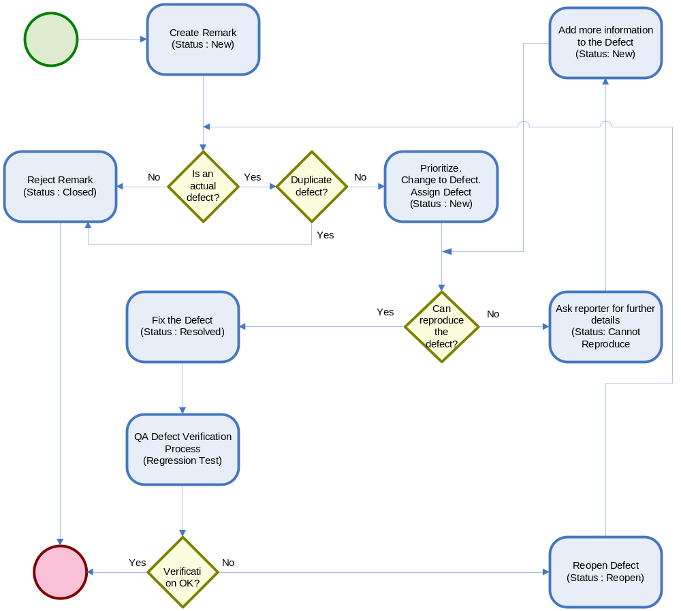

Defects are classified on two scales:
A. Severity Scale
B. Priority Scale

A. The Severity Scale indicates the impact of a failure caused by a fault. QA Engineer responsible for entering the change request will decide the severity. It can be classified into the following:
Severity | Guidelines
Critical | System Crash  Defects that have the potential to destabilize the system  Missing major functionality  Any defect that prevents execution of test cases
High | Erroneous functionality  Loss or corrupted data transformation  Unexpected functional behavior  Wrong/missing features in functionality  Major non-conformance to GUI standards  Workaround exists but is complicated
Medium | Errors in the display of graphics and content  Unexpected functional behavior which are not showstoppers  Minor non-conformance to GUI standards  Defect in code, but simple workaround exists
Low | Cosmetic errors  Defect causes minimal or unnoticeable problems

B. The Priority Scale indicates the urgency to fix a fault. Priority is decided by the Project Manager or an individual or a group appointed by him/her. Guidelines for priority are listed below:
Priority | Guidelines
High | Resolve Immediately
Medium | Resolve Pre-Release
Low | Desired but not urgent

  - Definition
<Gereral definitions>

What should come here???

Performance Deliverables

  - Performance Deliverables sign-off
The Performance testing team would be sharing the following Deliverables upon
Completing the Testing.

Performance closure report containing:

- Performance Benchmark
- Defects / Issues
- Observations
- Recommendation for Application server hardware and improvements for the application performances.

